I found JElastic a good company for providing docker hosting. Purchased account in app.cloudjiffy.com with capitalch… and …123.

With OTB node.js and postgresql it ran fine. Then I tried with custom node.js docker from docker hub. Install the new node.js environment from docker hub.

1. **Steps to create a custom node.js app from docker hub in cloudjiffy.com**

* Opened configs and went to Root folder. Created a new folder with name node and uploaded all node.js files in this folder.
* Used SSH🡪 cd /home/node. Originally it was in Root folder by default when you login through SSH. You are logged in as root user with all rights available. This is equivalent to SUDO in UBUNTU.
* **node server**
* My application of hellow world node application was using port 8080. When I gave default url of environment created it worked fine.
* **Now I wanted to run** app in port 8081. I changed the app for using port 8081 and uploaded it to /home/node folder. Then I created an endpoint through **settings icon in environment** row. I filled up following:
* 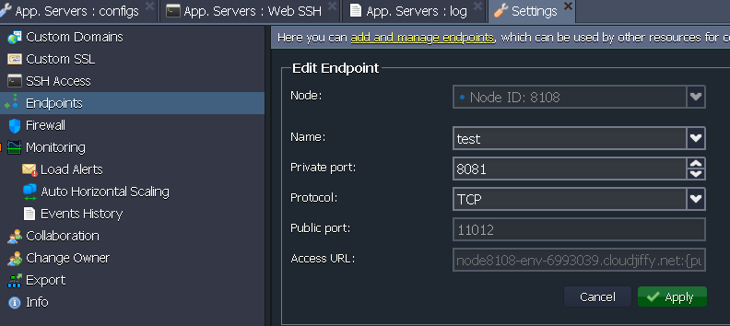

The public port and Access URL was auto filled by cloudjiffy.

The application worked

1. Steps to create a new postgresql in cloudjiffy from docker hub:

* Select docker tab in a new environment
* Select postgres and create from docker hub. Use new IP.
* In pgadmin create new server, give new ip, use user as postgres and password as received in email.

It worked. I was able to connect the postgresql database.

# Installing postgresql with plv8 extension 2.3.3 in jelastic

I used [waldo2188](https://hub.docker.com/u/waldo2188/)/[postgres-plv8](https://hub.docker.com/r/waldo2188/postgres-plv8/)

* For that I searched with name waldo2188 in docker registry and added the image and created the environment. Make sure that you create a public IP.
* I got a mail from cloudjiffy giving the password for root user.
* I created a new server in pgadmin giving the public ip and password.
* In database I gave sql command:
  + create extension if not exists plv8
  + select plv8_version();

plv8 version 2.3.3 was available of April 2018 which supported ES6.

Next I am going to use [**clkao**](https://github.com/clkao)**/**[docker-postgres-plv8](https://github.com/clkao/docker-postgres-plv8)